QEMULA Official Requirements




Table of signatures

12/12/2024
Summary

1. Introduction 1
1.1. Entities 1
2. General Project Description 3
2.1. General Structure 3
2.2. System Data Flow 5
3. QEMULA’s Use Cases 7
4. Requirements 8
4.1. Requirements Diagram and General Overview 10
4.2. Main Requirements 11
4.3. Emulation Requirements 15
4.4 Control Interface Requirements 18
4.5 Instrument Interface Requirements 23
4.6 Debug Interface Requirements 25
5. Projects Schedule 26
5.1. General Overview 26
5.2. Relation of Requirements and Releases 27

Introduction

The Embedded Electronic Systems Center (NSEE) of the Instituto Mauá de Tecnologia (IMT) has a solid record of accomplishment in developing solutions for space missions, which began in 2011 with the SimuCam project for the European Space Agency's (ESA) PLATO mission, in partnership with institutions such as LESIA, DLR, and IWF. Although SimuCam is not the focus of this work, its success positioned NSEE as an important collaborator in international space projects.
As a result of this expertise, NSEE was invited to participate in the VERITAS and EnVision missions led by NASA's Jet Propulsion Laboratory (JPL) and ESA. Both missions aims to study Venus to understand its geological evolution and assess conditions for life. Within them, the German Aerospace Center (DLR) is developing the Venus Emissivity Mapper (VEM), a spectrometer that includes an optical component and an electronic control unit called VenSpec-M. The software and optics of VenSpec-M are being developed by the DLR, and the partnership with NSEE involves the development of a virtualized version of the electronic interfaces of this instrument using the QEMU emulator.
The main goal of this project is to create a virtualized environment that allows for the development and validation of space software without the need for physical hardware, regarding the control unit VenSpec-M. The virtualization of VenSpec-M aims to faithfully replicate the characteristics and behavior of the real hardware, including the simulation of a virtual SpaceWire link for communication with other control units. This enables the configuration of test data and the injection of simulated faults, functionalities that would be unfeasible or risky on validated physical hardware. Additionally, the virtualized system will be integrated into continuous integration (CI/CD) pipelines, allowing for autonomous testing and validation of the software developed for VenSpec-M.

1.1. Entities

German Aerospace Center:
The German Aerospace Center, known as DLR (Deutsches Zentrum für Luft- und Raumfahrt), is Germany's national research center for aeronautics, space, energy, transport, and security. Established to conduct research and development activities in these fields, DLR plays a crucial role in advancing scientific knowledge and technological innovations, not just within Germany but globally.
DLR collaborates with various international partners, including space agencies like NASA and ESA (European Space Agency). Its involvement in major missions, such as those exploring Mars, the Moon, or studying Earth’s climate, highlights its global influence. For example, DLR is involved in high-profile missions like Mars Express, Rosetta, and VERITAS, providing essential technologies like scientific instruments and control systems.
DLR’s efforts position it as a leader in aerospace innovation, shaping the future of space exploration, air travel, and sustainable technology.

Embedded Electronic Systems Center:
The NSEE (Núcleo de Sistemas Eletrônicos Embarcados), or Embedded Electronic Systems Center, is a specialized research and development center within the Instituto Mauá de Tecnologia (IMT) in Brazil. The center focuses on the design, development, and integration of advanced embedded electronic systems, particularly for challenging applications in space, aeronautics, and other high-tech industries.
The NSEE is committed to technological innovation, integrating cutting-edge tools like continuous integration/continuous deployment (CI/CD) pipelines into its processes. This ensures that the software and hardware systems it develops are rigorously tested and validated through automated processes, enhancing the reliability and performance of the solutions for critical applications.
Through its expertise in embedded electronics and international collaborations, NSEE plays a crucial role in advancing space technology and other high-stakes sectors that require robust, reliable electronic systems.

General Project Description

2.1. General Structure

To provide a detailed description of the project, its overall structure and data flow will be specified with a focus on normal operation.

Figure 1 – General overview of QEMULA’s Structure.
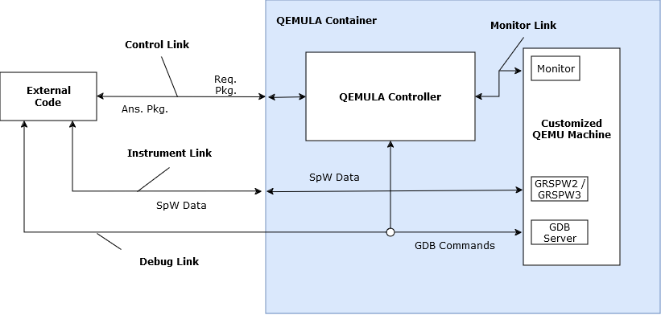
Source: the authors.

From Figure 1 above, it is possible to understand the general structure of QEMULA itself. Ideally, QEMULA is contained within a Docker container, isolated from an external system, and exposes at least three TCP/IP links that fall into three different categories:
- Control Link: Comprising a single TCP/IP link, it is responsible for receiving commands and sending reports related to the control and interaction with the emulated instrument.
- Instrument Link: Comprising an arbitrary number of TCP/IP links, it is responsible for the transmission and reception of data, which are essentially analogous to the SpaceWire protocol, in direct communication with the emulated instrument.
- Debug Link: Comprising a single TCP/IP connected to QEMULA Controller, it is responsible for sending and receiving Debug commands through an interface mediated by the GDB Server. Its presence at emulation time is optional: the user may configure the GDB Server exclusively by Instrument Link commands, debugging the test code indirectly.
For the last two categories of TCP/IP links, there is no immediate need for a dedicated interface with the emulated QEMU instrument, as they are directly connected to it. However, for the first category, the implementation of a controller is required, which will receive user commands and requests for the system based on a defined protocol. The controller will then take appropriate actions within the system or on the emulated instrument. In certain cases, the received command may also require information from the emulated instrument, in which case the controller will be responsible for generating and sending an appropriate report through the Control Link.
It is important to note that the modular structure presented here may undergo changes during the further development and expansion of QEMULA, to meet future requirements that may arise.

2.2. System Data Flow

Figure 2 – General overview of QEMULA’s Data Flow.
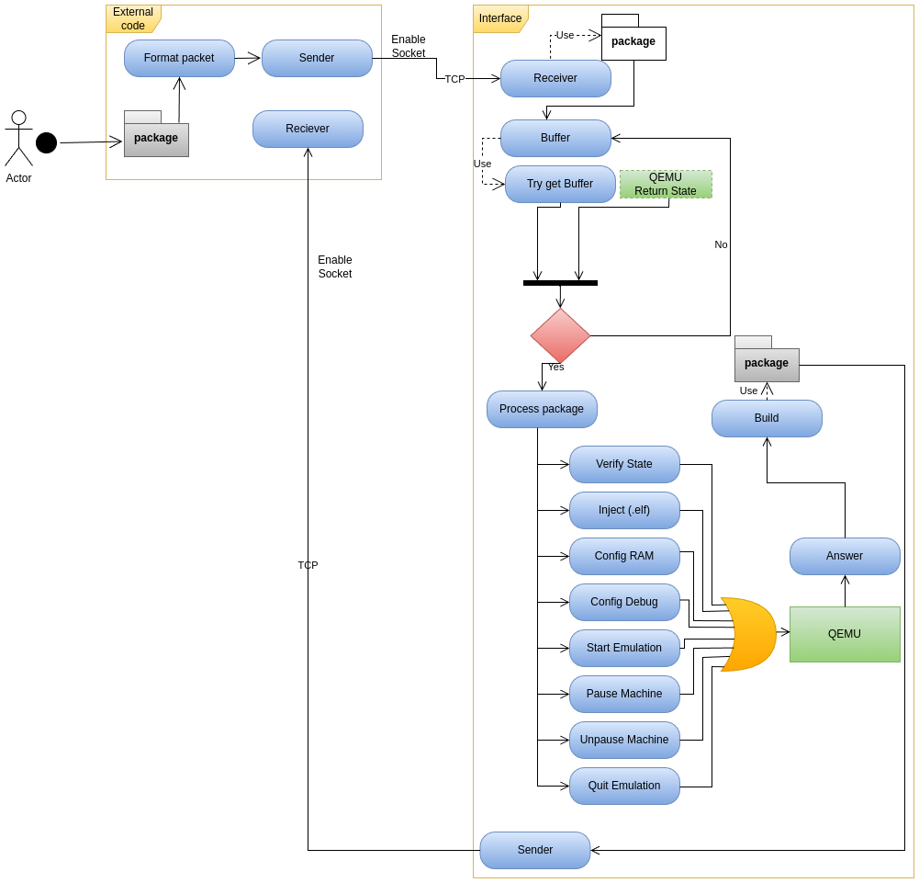
Source: the authors.

Figure 2 presents a flow diagram illustrating the data flow within QEMULA, an environment designed to simulate a range of use cases detailed in the accompanying documentation.
The process begins with the user submitting the packets that will be simulated. These packets are essential for driving the simulation scenarios. Once the packets are received, they undergo processing and normalization to conform to the internal protocol of the DLR CI-CD Actor interface.
After normalization, the packets are ready for transmission. The Socket Transmitter takes over at this stage, managing the transfer of control data between the user interface and the system’s Control Link (or Control Interface). This transmission occurs over TCP, so it is necessary to correctly configure the socket's address and transmission port.
The next stage in the data flow involves enabling the socket for communication. Although this description does not go into the potential causes of failure, it is assumed that the protocol message is successfully transmitted to the Control Interface. The first action of the Control Interface upon receiving the packet is to process its contents, which involves interpreting the header and body. This is handled by the Receiver routines, which classify the packets based on predefined message code tables. Once classified, the message is stored in a FIFO Buffer, where it waits for further processing.
Access to this buffer is managed by a routine known as Try Get Buffer, which retrieves the first item in the queue, allowing the packet to proceed. However, whether the packet advances depend on feedback from the QEMU State Machine, which operates in two primary states:
- CONFIG: Responsible for configuring all simulation parameters.
- RUN: Indicates that the emulated hardware is ready to accept simulation data.
Once the required conditions are met, the packet moves forward to the processing stage. During this phase, control methods are identified, and the system advances to execute one of several operations in QEMU. These include various commands, which can be seen at QEMULA’s User Manual (QEMULA-UM-I0.1).
Certain commands interact directly with the QEMU Monitor's library, issuing commands and receiving answers from the running QEMU machine. Before proceeding, the system requires a response from the Socket Controller channel. Once received, the control edge code compiles and repackages the packet, which is then externalized from the Docker environment via TCP. This is achieved through communication between the Sender and Receiver components of the user interface.
This description represents the first version of the QEMULA environment, focusing on the control requirements and the interface between QEMU, Docker, and the user. A careful review of the content is advised, and any necessary adjustments should be made to both the diagram and the accompanying text.

QEMULA’s Use Cases

The QEMULA system, essentially, encompasses two general use cases in its operation: system execution and system configuration.
In the configuration use case, four specific use cases are derived, namely the configuration of emulation parameters, code injection, logging setup, and housekeeping configuration. For the execution use case, three specific use cases are derived, comprising emulation control and management, interaction with the emulated instrument, and operation in debug mode. The overall representation of the system's use cases, and their respective derivations can be better visualized in Figure 1 below.
Figure 1 – General overview of QEMULA’s Use Cases.
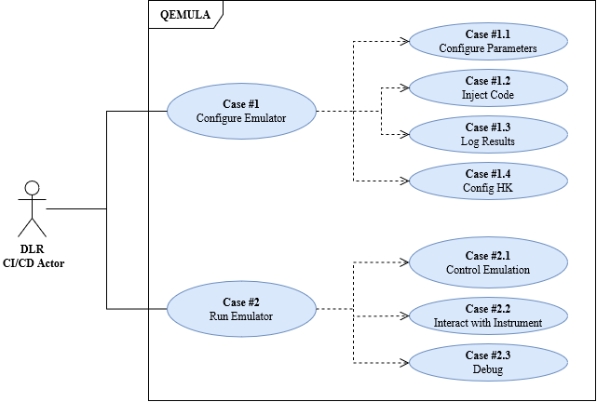
Source: the authors.

Requirements

This section outlines the expected requirements for the QEMULA project. Beginning with a general requirements diagram, these requirements will be detailed and specified for further clarity.
To clarify the types of imperative terms used in each specification, refer to Table 1 below.

Table 1 – Description of usual imperative terms used in requirements.
Terms Used | Description
Must / must not | Requirements that are expected to be implemented according to the specified guidelines.
Should / should not | Requirements that may or may not be implemented, based on the recommendations outlined in the specifications.
Source: the authors.

Complementing the terms presented, the types of verification designed for testing the proposed requirements will also be described. These definitions can be found in Table 2.

Table 2 – Description of verification terms used in requirements.
Terms Used | Description
Test | Specifications imposed by requirement must be verified, manually or automatically, against an expected behavior.
Verification | Specifications imposed by a requirement must have its functionality verified at code level.
Source: the authors.

4.1. Requirements Diagram and General Overview

In Figure 2 below, the conceptual groupings of the requirements are outlined, which include Main Requirements, Emulation Requirements, Control Interface Requirements, Debug Requirements, and Instrument Interface Requirements.

Figure 2 – General requirements of QEMULA.
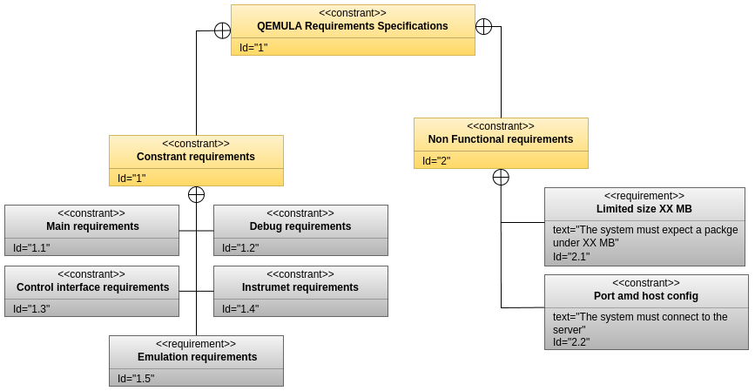
Source: the authors.

4.2. Main Requirements

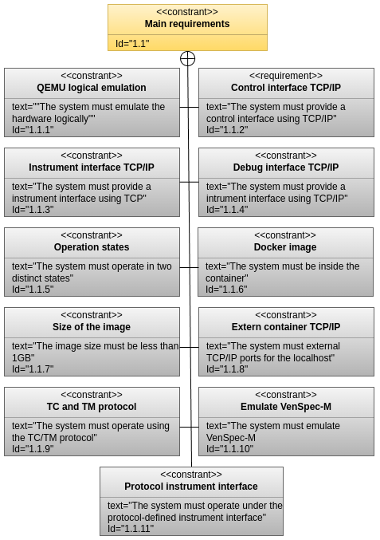

 | Title: | QEMU logical emulation
 | Type: | Functional
 | Verif.: | Test
 | LastEdit:
QEM-REQ-MA-01 | QEMULA must be capable of logically emulating the software interfaces of the VenSpec-M device.

 | Title: | Control interface TCP connected to QEMULA Controller
 | Type: | Functional
 | Verif.: | Verification
 | LastEdit:
QEM-REQ-MA-02 | QEMULA must provide a control interface using the TCP/IP protocol.

 | Title: | Instrument interface TCP
 | Type: | Functional
 | Verif.: | Verification
 | LastEdit:
QEM-REQ-MA-03 | QEMULA must provide an interface for the emulated instrument using the TCP/IP protocol.

 | Title: | Debug interface TCP
 | Type: | Functional
 | Verif.: | Verification
 | LastEdit:
QEM-REQ-MA-04 | QEMULA must provide a debug interface for the injected software using the TCP/IP protocol.

 | Title: | Operation states
 | Type: | Functional
 | Verif.: | Verification
 | LastEdit:
QEM-REQ-MA-05 | QEMULA must have two main operation states:  - CONFIG_STATE: directly related to the tasks and operations described in the system’s use case #1.  - RUN_STATE: directly related to the tasks and operations described in the system’s use case #2.

 | Title: | Docker image
 | Type: | Functional
 | Verif.: | Verification
 | LastEdit:
QEM-REQ-MA-06 | QEMULA’s system must be entirely packaged into a Docker image.

 | Title: | Size of the image
 | Type: | Non-functional
 | Verif.: | Verification
 | LastEdit:
QEM-REQ-MA-07 | QEMULA’s image must be smaller than 1 GB in disk.

 | Title: | Computer requirements
 | Type: | Non-functional
 | Verif.: | Verification
 | LastEdit:
QEM-REQ-MA-08 | QEMULA’s image should use, at its execution, at least 1 CPU and 1 GB of RAM of the host machine.

 | Title: | Extern container TCP
 | Type: | Functional
 | Verif.: | Test
 | LastEdit:
QEM-REQ-MA-09 | QEMULA’s container should have its TCP/IP ports connected to the localhost of the host machine.

 | Title: | Modular architecture
 | Type: | Non-functional
 | Verif.: | Verification
 | LastEdit:
QEM-REQ-MA-10 | All QEMULA’s components should have a modular architecture¹.
Note 1: modular architecture enables future customization and adaptation of the system to meet upcoming requirements.

 | Title: | TC and TM protocol
 | Type: | Non-functional
 | Verif.: | Verification
 | LastEdit:
QEM-REQ-MA-11 | QEMULA’s control interface must operate under an idealized TC/TM protocol.

 | Title: | Emulate VenSpec-M
 | Type: | Functional
 | Verif.: | Verification
 | LastEdit:
QEM-REQ-MA-12 | QEMULA’s instrument interface must be connected to the emulated stdout devices of VenSpec-M.

 | Title: | Instrument interface
 | Type: | Non-functional
 | Verif.: | Verification
 | LastEdit:
QEM-REQ-MA-13 | QEMULA’s instrument interface must operate under an idealized protocol.

4.3. Emulation Requirements

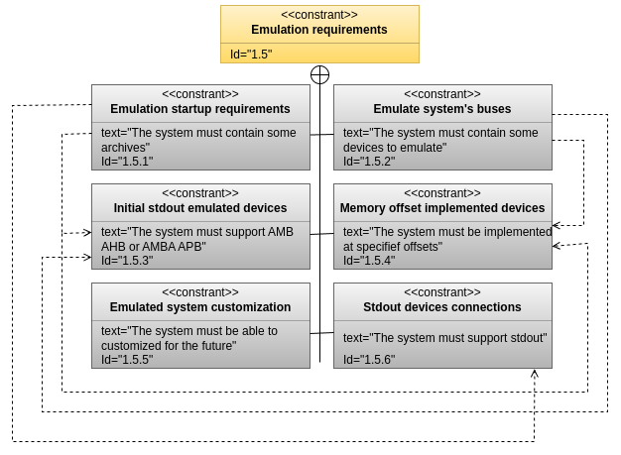

 | Title: | Emulation startup requirements
 | Type: | Functional
 | Verif.: | Verification
 | LastEdit:
QEM-REQ-EM-01 | First version of QEMULA must have the capability of emulating, at logical level, the following internal devices of RA-01 document:  - A LEON3/FT processor.  - An AHBSTAT register.  - A GPTIMER.  - A FTMCRL.  - An IRQMP.  - An AHBROM.  - A FTAHBRAM.

 | Title: | Initial stdout emulated devices
 | Type: | Functional
 | Verif.: | Verification
 | LastEdit:
QEM-REQ-EM-02 | First version of QEMULA must have the capability of emulating, at logical level, the following stdout devices of RA-01 document:  - A GRSPW and GRSPW2.  - An APBUART.

 | Title: | Emulated system’s buses
 | Type: | Functional
 | Verif.: | Verification
 | LastEdit:
QEM-REQ-EM-03 | QEMULA’s emulated devices specified in QEM-REQ-EM-01 and QEM-REQ-EM-02 must be interconnected by an AMBA AHB or AMBA APB buses.

 | Title: | Memory offset of implemented devices
 | Type: | Functional
 | Verif.: | Verification
 | LastEdit:
QEM-REQ-EM-04 | QEMULA’s emulated devices specified in QEM-REQ-EM-01 and QEM-REQ-EM-02 must be implemented at specified offsets, based on VenSpec-M configuration.

 | Title: | Emulated system customization
 | Type: | Non-functional
 | Verif.: | Verification
 | LastEdit:
QEM-REQ-EM-05 | QEMULA’s emulated system should be able to be customized and incremented over its future versions¹².
Note 1: this requirement matches the specification proposed at QEM-REQ-MA-10.
Note 2: ultimately, this would lead to entirely emulating all of VenSpec-M software interfaces device, proposed in QEM-REQ-MA-01.

 | Title: | Stdout devices connection
 | Type: | Functional
 | Verif.: | Verification
 | LastEdit:
QEM-REQ-EM-06 | QEMULA’s emulated stdout devices, specified in QEM-REQ-EM-02, must be internally connected to the system’s instrument interface, specified in QEM-REQ-MA-03.

4.4 Control Interface Requirements
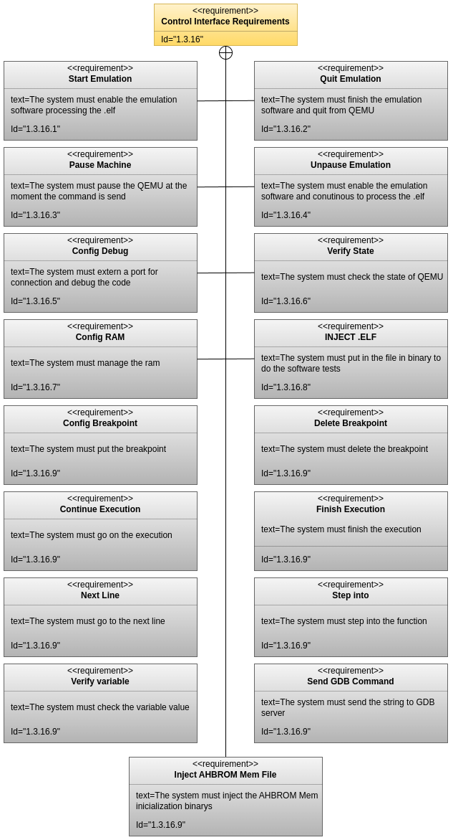
 | Title: | Control interface connection
 | Type: | Functional
 | Verif.: | Verification
 | LastEdit:
QEM-REQ-CI-01 | QEMULA’s control interface must comprehend only 1 TCP/IP link.

 | Title: | Protocol based on TC and TM
 | Type: | Functional
 | Verif.: | Verification
 | LastEdit:
QEM-REQ-CI-02 | QEMULA’s control interface protocol must be based on TCs (Requisitions) and TMs packages (Answers).

 | Title: | User management TC’s
 | Type: | Functional
 | Verif.: | Verification
 | LastEdit:
QEM-REQ-CI-03 | A control protocol requisition, as specified in QEM-REQ-CI-02, must always be generated by the user and sent to QEMULA’s system.

 | Title: | QEMULA management TM’s
 | Type: | Functional
 | Verif.: | Verification
 | LastEdit:
QEM-REQ-CI-04 | A control protocol answer, as specified in QEM-REQ-CI-02, must always be generated by QEMULA and sent to the user.

 | Title: | Requisitions implies in answers
 | Type: | Functional
 | Verif.: | Test
 | LastEdit:
QEM-REQ-CI-05 | Every requisition package sent by the user must imply in an answer sent by QEMULA¹.
Note 1: this statement is true even if QEMULA doesn’t have the need to return extra information.

 | Title: | Buffer stored
 | Type: | Non-functional
 | Verif.: | Test
 | LastEdit:
QEM-REQ-CI-06 | QEMULA’s control interface should have a buffer to store received requisitions until it can process them.

 | Title: | Only one package
 | Type: | Functional
 | Verif.: | Test
 | LastEdit:
QEM-REQ-CI-07 | Each requisition package type must be associated with only one answer package type.

 | Title: | Packages and association with operations
 | Type: | Functional
 | Verif.: | Test
 | LastEdit:
QEM-REQ-CI-08 | Each requisition and answer packages pair must be associated with only one system’s operation¹.
Note 1: like pausing the emulation, dumping memory…
 | Title: | Packages and association with the system’s states
 | Type: | Functional
 | Verif.: | Verification
 | LastEdit:
QEM-REQ-CI-08 | Each requisition and answer packages pair must be associated with only one of the system’s states¹, except for the operation to verify QEMULA’s current state.
Note 1: CONFIG_STATE and RUN_STATE, as described in QEM-REQ-MA-06.
 | Title: | Package’s modularity
 | Type: | Functional
 | Verif.: | Verification
 | LastEdit:
QEM-REQ-CI-09 | Requisition and answer packages must be modular¹.
Note 1: this ensures that future customization and addition of new requisitions and answers is possible and viable.
 | Title: | Package’s identification
 | Type: | Functional
 | Verif.: | Test
 | LastEdit:
QEM-REQ-CI-10 | Requisition and answer packages must be identified by an ID within the same system’s execution.

 | Title: | Package’s CRC calculation
 | Type: | Functional
 | Verif.: | Test
 | LastEdit:
QEM-REQ-CI-11 | Requisition and answer packages must have implemented a Cyclic Redundancy Code (CRC) verification.

 | Title: | Status of the answer packages
 | Type: | Functional
 | Verif.: | Test
 | LastEdit:
QEM-REQ-CI-12 | Answer packages must contain an execution status¹ related to its relative requisition sent previously to QEMULA.
Note 1: the execution status should be better specified at the requisition and answer packages description.

 | Title: | Filtration of faulty requisitions
 | Type: | Functional
 | Verif.: | Test
 | LastEdit:
QEM-REQ-CI-13 | Faulty requisitions must be filtered and return a correspondent answer with an adequate status.

 | Title: | Package’s structure
 | Type: | Functional
 | Verif.: | Test
 | LastEdit:
QEM-REQ-CI-14 | Requisition and answer packages must have standardized¹ headers and body contents.
Note 1: for each type of package, the content of its header and body must be specified, based on the specific type of function to which it is related.

 | Title: | Initial control operations
 | Type: | Functional
 | Verif.: | Test
 | LastEdit:
QEM-REQ-CI-15 | Requisition and answer packages must be capable of covering these operations¹, on the first version:  - Verify system state.  - Inject external code.  - Configure debug mode.  - Configure emulated machine RAM.  - Configure AHBROM memory binaries.  - Start emulation.  - Pause emulation.  - Unpause emulation.  - Dump on emulated system’s memory.  - Load on emulated system’s memory.  - Read on emulated system’s IO.  - Write on emulated system’s IO.  - Stop emulation.  - Configure Breakpoint  - Delete Breakpoint  - Continue Execution  - Finish Execution  - Step Into  - Next Line  - Verify Variable  - Send GDB Command

 | Title: | Limited size 500 MB
 | Type: | Non-functional.
 | Verif.: | Test
 | LastEdit:
QEM-REQ-CI-16 | QEMULA’s control interface must be able to process and generate, at a maximum level, packages up to 500 MB of size¹.
Note 1: this is especially relevant to the “Inject external code” operation pointed in QEM-REQ-CI-14, because of the possible size of the software to be tested in QEMULA.

4.5 Instrument Interface Requirements

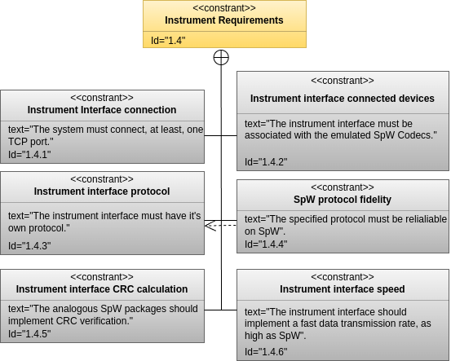

 | Title: | Instrument interface connection
 | Type: | Functional
 | Verif.: | Verification
 | LastEdit:
QEM-REQ-IE-01 | QEMULA’s instrument interface must comprehend, at least, 1 TCP/IP link¹.
Note 1: Depending on the version of the emulated instrument implemented, there may be a varying number of stdout-type devices that require a specific TCP/IP link.

 | Title: | Instrument interface connected devices
 | Type: | Functional
 | Verif.: | Verification
 | LastEdit:
QEM-REQ-IE-02 | QEMULA’s instrument interface must be logically associated¹ with the emulated system’s SpW Codecs and APBUARTs.
Note 1: this term is utilized here, because it’s not imperatively necessary that the SpW Codecs must be directly connected with the instrument TCP/IP links.

 | Title: | Instrument interface protocol
 | Type: | Functional
 | Verif.: | Verification
 | LastEdit:
QEM-REQ-IE-03 | QEMULA’s instrument interface must have its own protocol, analogous to SpW and UART, but running over a TCP/IP interface.

 | Title: | SpW protocol fidelity
 | Type: | Functional
 | Verif.: | Verification
 | LastEdit:
QEM-REQ-IE-04 | QEMULA’s instrument interface protocol, characterized by QEM-REQ-IE-3, must have a standardized structure reliable on SpW protocol¹ and UART.
Note 1: including its package structure, control and data characters and timecodes, especially.

 | Title: | Instrument interface CRC calculation
 | Type: | Functional
 | Verif.: | Test
 | LastEdit:
QEM-REQ-IE-05 | QEMULA’s instrument interface analogous should implement CRC verification.

Note 1: this ensures transferred data liability.

 | Title: | Instrument interface speed
 | Type: | Non-functional
 | Verif.: | Test
 | LastEdit:
QEM-REQ-IE-06 | QEMULA’s instrument interface should implement a fast data transmission rate, as high as SpW links used in VenSpec-M¹.
Note 1: this depends directly of DLR’s specifications, as shown in document RA-01.

4.6 Debug Interface Requirements

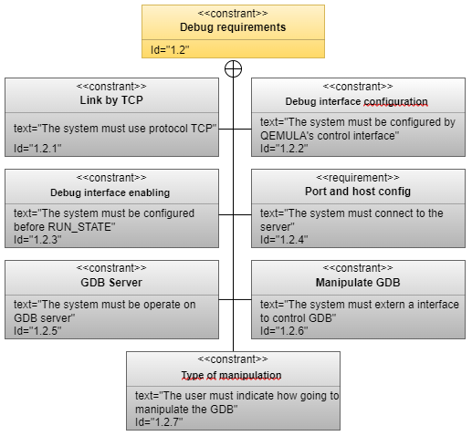

 | Title: | Link by TCP
 | Type: | Functional
 | Verif.: | Verification
 | LastEdit:
QEM-REQ-DI-01 | QEMULA’s debug interface must comprehend only 1 TCP/IP link for inside configurations.

 | Title: | Debug interface configuration
 | Type: | Functional
 | Verif.: | Test
 | LastEdit:
QEM-REQ-DI-02 | QEMULA’s debug interface must be configured through QEMULA’s control interface.

 | Title: | Debug interface enabling
 | Type: | Functional
 | Verif.: | Test
 | LastEdit:
QEM-REQ-DI-03 | QEMULA’s debug interface, when previously configured, must enable connection at the system’s RUN_STATE.

 | Title: | Port and host configuration
 | Type: | Functional
 | Verif.: | Test
 | LastEdit:
QEM-REQ-DI-04 | QEMULA’s debug interface, when previously configured, must enable connection to QEMULA’s Controller.

 | Title: | GDB server
 | Type: | Functional
 | Verif.: | Test
 | LastEdit:
QEM-REQ-DI-05 | QEMULA’s debug interface must be operated under a GDB server.

 | Title: | Type of manipulation
 | Type: | Functional
 | Verif.: | Test
 | LastEdit:
QEM-REQ-DI-06 | QEMULA’s debug interface must be able to manipulate the injected code, utilizing all functionalities provided by either GDB or QEMULA´s interface.

Projects Schedule

TODO

5.1. General Overview

TODO

5.2. Relation of Requirements and Releases

TODO

